Roomify
Architecture
Components, request flow, data model, security and deployment topology
Team Bootcamp2Roomify
Release v1.0.0 (demo mode)
24 October 2026

Roomify turns one photo of a person's own room into a saved, budget-aware and rental-aware redesign project. It is built as three services — a web frontend, an API and a computer-vision service — plus PostgreSQL, object storage and the OpenAI API. This document describes how they fit together, how a request flows through them, what is stored, and how privacy is enforced.

System overview
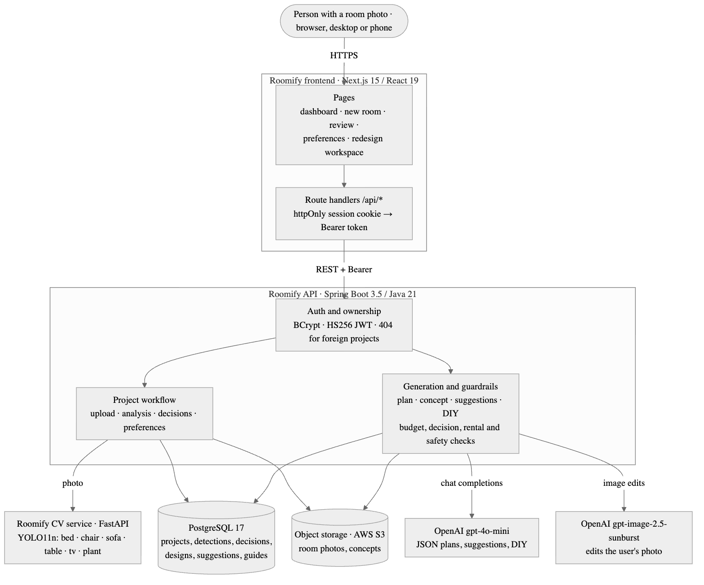
Figure 1. Roomify system architecture: browser, Roomify frontend, Roomify API, Roomify CV service, OpenAI, PostgreSQL and object storage.
Component | Technology | Responsibility
Roomify frontend | Next.js 15.5, React 19, TypeScript, Tailwind CSS | Pages for the whole journey; same-origin route handlers (/api/*) that keep the access token in an httpOnly cookie and forward it to the API as a Bearer token
Roomify API | Spring Boot 3.5, Java 21 | Accounts and ownership, project workflow, image storage, calls to the CV service and OpenAI, and all validation of generated output
Roomify CV service | FastAPI, Ultralytics YOLO11n | Detects six furniture classes in a photo; reachable only by the API
PostgreSQL 17 | Flyway migrations V1–V10 | Users, projects, detections, decisions, preferences, design history, suggestions, DIY guides
Object storage | AWS S3 (local disk in development) | Original room photos and generated concept images
OpenAI API | Chat Completions (gpt-4o-mini), Images edits (gpt-image-2.5-sunburst) | Redesign plans, suggestions and DIY guides as JSON; the visual concept
The browser never calls the API or the CV service directly and never sees the access token. All three services ship as pinned container images.

Request flow
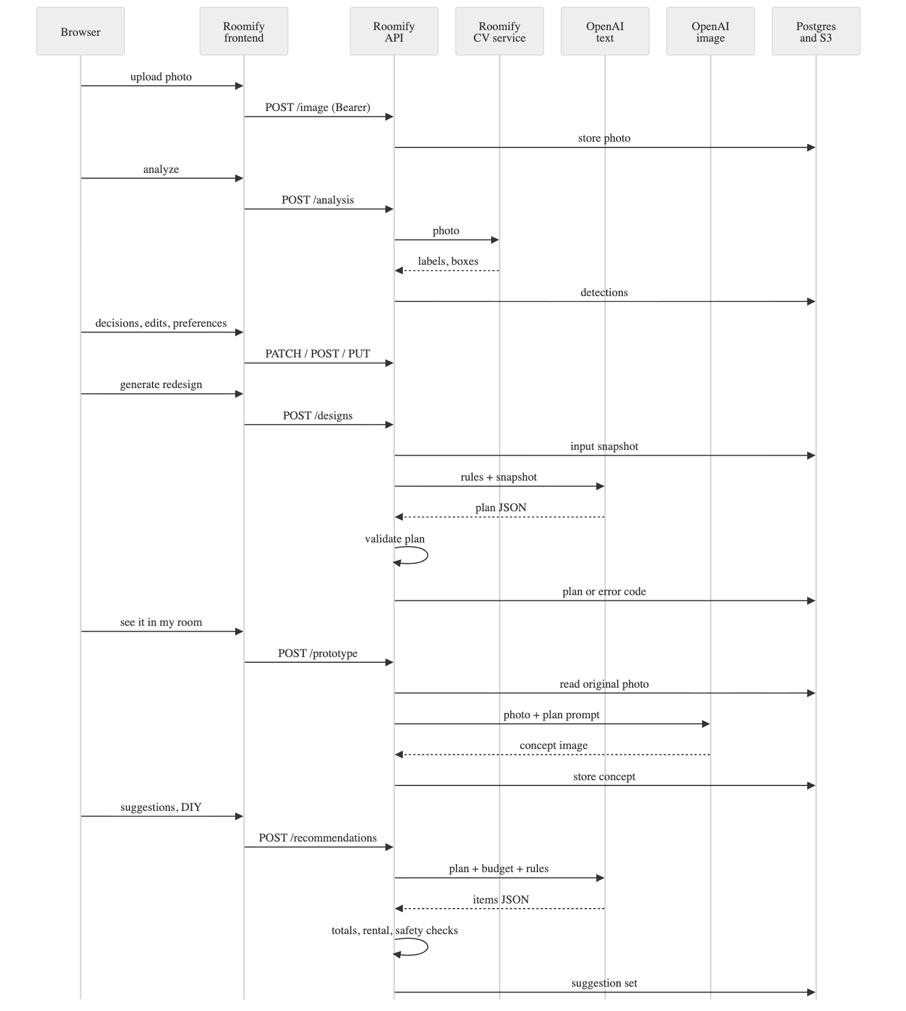
Figure 2. Roomify request flow from photo upload to plan, visual concept, suggestions and DIY guide.
- Upload. The photo is validated (JPG or PNG, size and signature), stored, and linked to the project.
- Analysis. The API sends the photo to the CV service and stores each detection with a stable UUID.
- Review. The person sets Keep, Replace, Remove or Unsure per item and can rename, remove or add items; added and renamed items are marked as user-confirmed.
- Preferences. Style, colours, purpose, budget, Rental-Friendly Mode and free-text requirements.
- Plan. The API stores an immutable input snapshot, asks the text model for a plan in a fixed JSON schema, then validates it in code: every item with its saved decision, matching instructions, exact budget arithmetic within the budget, no permanent work in rental mode, uncertainty wording for low-confidence items. One corrective retry; otherwise the attempt is stored as failed with a code.
- Visual concept. The photo recorded in the snapshot is edited by the image model with a prompt derived from the validated plan, then stored.
- Suggestions and DIY. The text model proposes items; the API rounds prices, computes totals, checks cheaper alternatives and rental wording, and stores the set. DIY guides must be beginner level, cost no more than buying, and pass a safety filter.
No database transaction stays open while a provider is working, and nothing partially generated is ever shown.

Data model
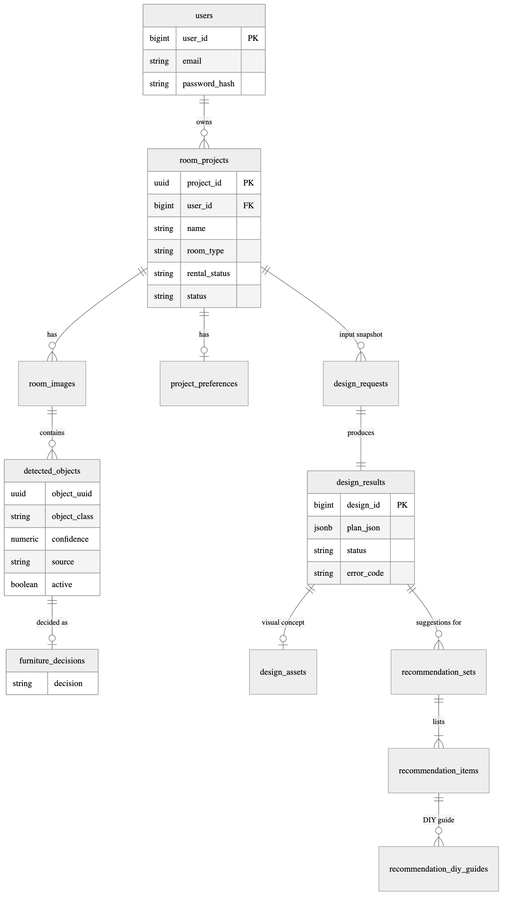
Figure 3. Roomify main tables and relationships.
Each generation keeps the exact input it was made from (design_requests.input_snapshot), the provider, model and prompt version, the outcome and a stable error code. Detections are never deleted, only deactivated, so design history stays explainable. Money is stored as NUMERIC(12,2) and handled as BigDecimal; database CHECK constraints repeat the most important rules (totals, statuses, currency).

Security and privacy
Concern | Design
Authentication | Email and password (BCrypt); stateless HS256 access tokens, 1 hour by default
Token handling | Stored only in an httpOnly, SameSite=Lax cookie (Secure in production) set by the frontend's route handlers
Authorisation | One rule covers every /api/projects/{id}/** route; another user's project returns the same 404 as a missing one
Generated content | Treated as untrusted input; validated before storage; provider error messages never shown or logged
CV service | No public address; its image_url input rejects non-public targets (SSRF) and does not follow redirects
Secrets | Only .env.example files in git; full history scanned with no findings

Deployment topology (proposed)
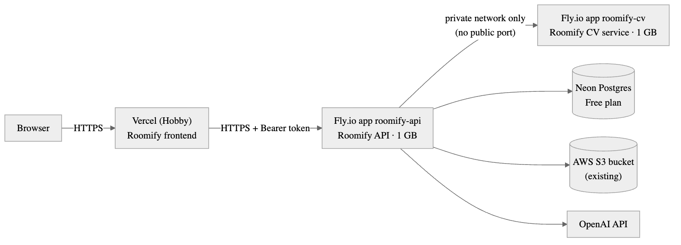
Figure 4. Proposed Roomify deployment: Vercel for the frontend, Fly.io for the API and a private CV service, Neon Postgres and the existing S3 bucket.
This topology is approved and configured but not yet deployed (Deployment has the blockers). Costs, steps and risks are in the Deployment document.

Architectural decisions
Decision | Reason
Three services instead of one | Keeps PyTorch out of the JVM host, lets the CV service stay private, and lets each part scale or be replaced independently
Backend-for-frontend bridge in Next.js | The token never reaches browser JavaScript; no CORS surface on the API
"The model proposes, the server disposes" | LLM output is checked by deterministic code before it is stored or shown
Immutable input snapshots | The concept always matches its plan; changed inputs mid-generation are detected
Model names are configuration | OpenAI retired one model during the build; switching needs no code change

